**River Hongbao Festival**

Tourists come to Singapore on the occasion of the River Hongbao festival. Held at the Floating Platform Marina Bay, this iconic event has become an indispensable tradition in Singapore's Lunar New Year celebrations for both locals and visitors. This lively festival offers a special Chinese cultural experience – from giant lanterns to mouthwatering food – a feast for your senses.

Great experiences at River Hongbao Festival

With countless ways to welcome the New Year imbued with unique traditional culture, the River Hongbao festival - Lunar New Year on the riverside of the Lion Island always attracts a large number of international tourists to mingle in the atmosphere. this fun, vibrant atmosphere. The word 'Hongbao' means red envelopes, meaning money to celebrate the Lunar New Year - a symbol of good luck.

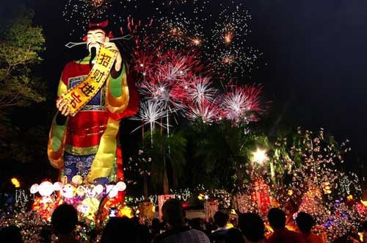

River Hongbao Festival honors the beauty and quintessence of Chinese culture with thousands of years of history. Traveling to Singapore, visitors will have the opportunity to discover more about Chinese culture through a series of activities of the River Hongbao festival. From the brilliant fireworks displays that take place every day during the festival, to the street art performances, or the display of large statues of Chinese mythology…

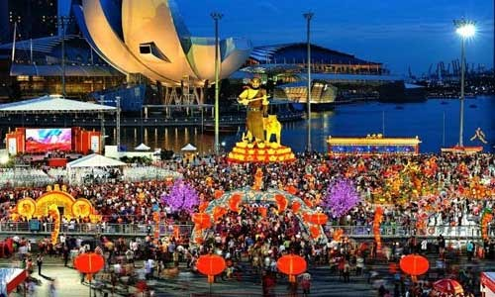

Usually held at Esplanade Park, the splendid River Hongbao festival with a series of entertainment activities for both adults and children, as well as the elderly, provides an ideal playground for the whole family. Moreover, the River Hongbao festival also has interesting cultural exchange programs between Singapore and China. On the sidelines of the River Hongbao, there is also a lantern festival that attracts visitors by the sparkling light from the lanterns welcoming Chunjie (spring).

You will have to admire the extremely impressive lanterns, depicting images in Chinese myths and legends, hand-made by craftsmen from China on the spot. Popular models of lanterns include the God of Fortune lanterns, of course, the 12 Zodiacs.

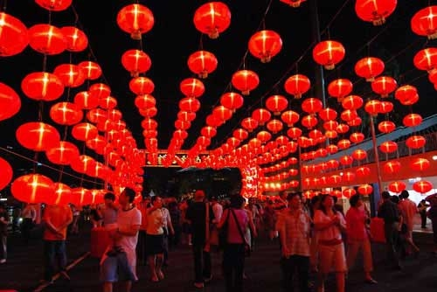

With a variety of side activities, from roller coasters to make-up activities, you're sure to never get bored. Peking opera performances along with other street performances complete this colorful, monumental experience.

Tourists should not miss visiting the beautiful unique lanterns depicting famous Chinese characters. In addition, the convoys of the Chingay Parade will surely impress many people during the River Hongbao festival.

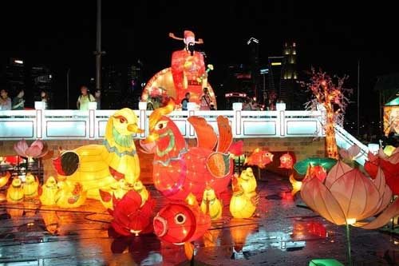

In addition to traveling to Singapore on this occasion, visitors can also enjoy rich Chinese cultural activities such as calligraphy, quizzes.

Along the food streets of Singapore on the occasion of the River Hongbao festival, visitors will enjoy traditional Chinese dishes. Visitors will be surprised and delighted by the display of the stalls, in which, especially, there are lanterns made from crockery spoons with sugar.

River Hongbao Festival - a festival for everyone

Put aside the tired worries of life to enjoy a colorful festival, amidst a lively concert of sounds and images. Pamper your taste buds with a range of mouth-watering specialties on sale at the largest outdoor Food Street in Singapore.

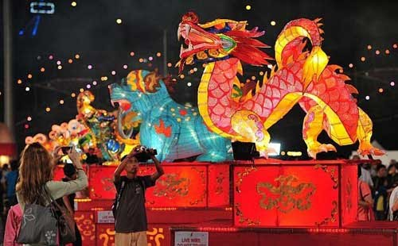

You love watching fireworks. If so, you're sure to love the opening night of the River Hongbao Festival as well as the New Year's Eve countdown event – each with its own fireworks display to celebrate the new year in cheerful, lucky style. lucky.

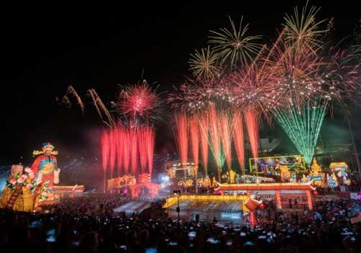

Visitors who have the opportunity to attend the River Hongbao festival will feel happy, immersed in the vibrant atmosphere of activities taking place during the festival. Besides entertainment activities, special art performances will make visitors never forget.

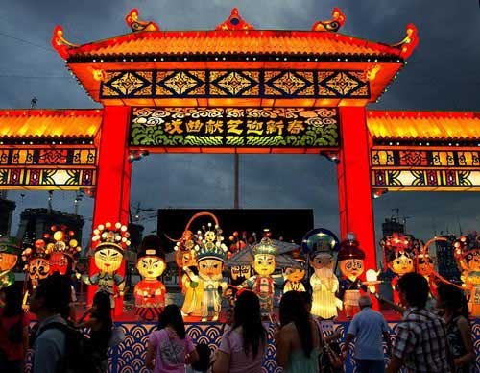

Do not miss the opportunity to travel to Singapore to visit the streets firsthand and experience the lively and splendid atmosphere of the unique Chinese festival River Hongbao on the extremely beautiful Lion Island. You will have a meaningful trip to Singapore, as well as great experiences of this beautiful, modern, hospitable country. With the meaning of the River Hongbao festival - bringing visitors the luck and happiness of a new year has come, you will feel so happy as well as lucky to experience a special festival.